JOUR 4251
Advertising in a diverse and global marketplace

Segmentation

Dividing the audience into manageable segments based on certain characteristics

● Demographics
● Lifestyle
● Behavior
Snooki Chrissy Teigen
Individual differences State vs. trait

State: in response to a message Trait: within the person
Happy person or because of a message?
Subcultures
Subculture is a group that shares certain beliefs, values, and customs and exists within a larger society
Based on (1):
● Ethnicity
● Religion
● Geography/location ● Age
● Gender
● Lifestyle
Norms
What they think similar others want them to do; what they think similar others do themselves
Values
What is important to people
(2) Core cultural values and customs shared by most of the population
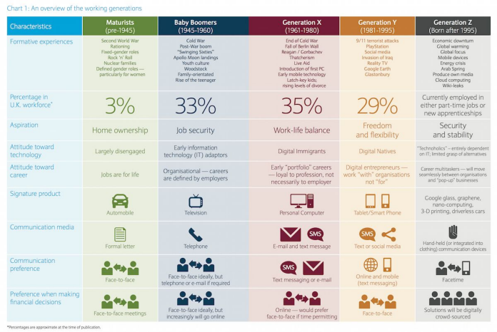
Social class
The division of members of a society into a hierarchy of distinct status classes, so that members of each class have relatively the same status and members of all other classes have either more or less status.
● Societal prestige
● Income or wealth
● Social connections
● Power
● Eduction
Upward mobility (or downward mobility)
Families
Families are the first consumer reference group - where you see what you should be doing
Training consumerism (socialization)
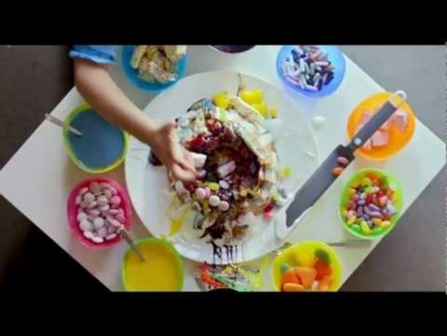
Socialization in families
Children impart basic values and modes of behavior consistent with the culture
Moral and religious principles, interpersonal skills, dress and grooming standards, appropriate manners and speech, selection of suitable educational and occupational or career goals
Consumer socialization
The process by which children acquire the skills, knowledge, attitudes, and experiences necessary to function as consumers
Family influences
Preferences of children
● Start early - we see it as soon as they can communicate (point in stores before they can walk)
● Among the first words are consumer goods (e.g. Elmo) ● Fascinated by products, and at the same time, sometimes could care less (play with the box of the toy)
Intergenerational socialization: product loyalty transferred from parent to child
Socialization does not stop - ongoing - adults continue the process Friends, Marriage => share preferences
What’s next?
● Watch the video of the guest speaker!
● Submit reading response #10
○ Articles: Strycharz et al (2019) + Segijn (2019) ○ Deadline: April 16, 2:30 pm
● Submit review question by April 16, 2:30 pm
● Assignment #4
○ We discussed all contents needed for this assignment ○ Deadline: April 23, 2:30 pm
Cultural Strategy
University of Minnesota
JOUR 4251 Psychology of Advertising Chelsea St. Clair

Hi! I’m Chelsea St. Clair. I am…
✮ A Cultural Strategist at Sparks & Honey
✮ The former West Coast Multicultural Advertising Intern Program Alumni Council Chair
✮ A 2019 Cannes Can Diversity Ambassador
What does a Cultural Strategist do?
“I work at a tech-led consultancy and work as a strategist helping companies with business solutions, product innovation, and communications strategies. Essentially I help answer seemingly impossible questions for clients who are open to transformative solutions”.
✮ Unpack Culture Daily
✮ Have a Point of View
✮ Real-Time Riffing
✮ Be Empathetic
✮ Tell a Story
Why are diverse teams important? Diverse teams can provide several benefits:
✮ More money
✮ Better Results
✮ A more representative audience
✮ Create more relatable content
✮ Less bias
Tips for the industry!
Advertising can provide a lot of really cool opportunities, here’s my advice on getting in:
✮ Find a Mentor
✮ Stand out
✮ Look for productive work cultures
✮ Read advice from communities like We Are Next
Tips for finding a job upon graduation!
Finding your perfect fit in advertising can be easy under the right circumstances, but a pandemic can definitely hinder your ability:
✮ Be flexible
✮ Be proactive
✮ Pitch your unique skills

Keep up with me!
✮ Email:
chelsclair@gmail.com
✮ LinkedIn:
https://www.linkedin.com/in/chelsclair/
✮ Twitter/Insta:
@chels_clair
*please include your class number or university when emailing me so I know who you are!

